CHEMICAL ENGINEERING TRANSACTIONS  VOL. , 2023 | A publication of
The Italian Association
of Chemical Engineering
Online at www.cetjournal.it

Guest Editors: David Bogle, Flavio Manenti, Piero Salatino
Copyright © 2023, AIDIC Servizi S.r.l.
ISBN 979-12-81206-04-5; ISSN 2283-9216

Thermal Methane Cracking on molten metal: Techno-economic assessment
Emma Palo, Vittoria Cosentino*, Gaetano Iaquaniello
ªNextChem Spa, Via di Vannina 88/94, 00156 Rome, Italy
*v.cosentino@nextchem.it
Close to 80% of hydrogen is currently produced through emissions-intensive natural gas reforming and coal gasification, with almost all the rest being by-product hydrogen produced in facilities designed for other products. To significantly contribute to the clean energy transition, it is critical to develop low-carbon hydrogen production routes that can replace current production and at the same time expand production capacity to meet new demands. The two main low-carbon production routes are Steam Methane Reforming coupled with CCUS (blue H₂) or water electrolysis (green H₂); however, a new path based on methane pyrolysis is becoming more and more interesting in the last years. This process involves producing H₂ with solid carbon instead of CO₂ (turquoise H₂). The aim of this article is to present a new scheme for Hydrogen production through the cracking of methane using renewable energy. The process is based on a molten metal reactor where the main reaction takes place inside the liquid bath: the molten metal bath in fact enhances heat transfer and can facilitate carbon removal. A techno-economic assessment for distributed H₂ is analysed and reported. Finally, methane cracking performances are compared to conventional H₂ production processes.
  - Introduction
Climate change is the main emergency issue of the last years. European Union targeting is climate neutrality in the 2050 that means that Europe needs to be carbon neutral already years before and decarbonization is the only way to meet this target since renewable (and/or nuclear) electricity alone will never be able to provide all our energy needs.
Clean energy technology deployment must accelerate rapidly to meet climate goals. Momentum for clean energy transitions is accelerating, driven by increasingly ambitious energy and climate policies, technological progress and renewed energy security concerns following the Russia invasion of Ukraine. Clean energy investment representing 70% of the growth in total energy sector investment, up 10% relative to 2021. However, fossil fuels still account for 80% of the primary energy mix (IEA, 2023).
In this framework, hydrogen will play a crucial complementary role. Demand for hydrogen has more than tripled since 1975 and continues to grow. The total productivity amount to around 140 million tons of hydrogen each year, of which two-thirds is pure hydrogen and one-third is syngas (IEA, 2023; BakerMcKenzie, 2020).
Hydrogen is today mainly produced from fossil fuels resulting in close to 900Mt of CO₂ emissions per year. About 48% of H₂ comes from natural gas through the Steam Reforming (SMR) process, 30% from naphtha/oil reforming in the chemical industry and 18% from coal gasification. Only the remaining 4% is generated by water electrolysis, allowing a CO₂-free process, only if the electricity comes from renewable sources (Msheik et al., 2021; IEA, November 2021). The last IEA report on Energy Perspective (IEA, 2023) identified six clean energy and technology supply chains, based on their importance to the energy transition in the Net Zero Emissions Scenario and which contribute around half of the cumulative emissions reductions to 2050, in which low-emission hydrogen is present. Among the technologies identified in its energy supply chains, the two main production routes remain Natural Gas-based plants with Carbon Capture and Storage (CCUS) (Blue H₂) and electrolysis (Green H₂). However, a new path based on methane pyrolysis is becoming more and more interesting in the last years and may represent an interesting option during the transition to a long-term sustainable society (Sanchez-Bastardo et al., 2020). This technology is based on the splitting of methane into hydrogen and carbon in the form of coke (Turquoise H₂), without any associated CO₂ emissions, which is also much easier to sequester than CO₂ from the SMR process (Harrison, 2021; Catalan & Rezaei, 2020).
Methane cracking is endothermic and characterized by strong kinetic limitation due to high activation energy required to break the C–H bond with an activation energy comprised between 356 and 452 kJ/mol (Msheik, et al., 2021).
$CH_{4 (g)}=2H_{2 (g)}+C_{(s)}$ $∆H_{298K}^{0}=-74.8$ kJ/mol (1)
The reaction can occur in thermal, catalytic and combined process. Thermal cracking occurs theoretically above 300°C; however, only around 1000°C reasonable high conversion can be reached (Msheik et al., 2021). Figure 1 shows CH₄ conversion calculated at equilibrium at different pressure and temperature using Aspen Plus software v11 by Aspen Tech, which presents the same trend reported in literature (Pérez et al., 2021).

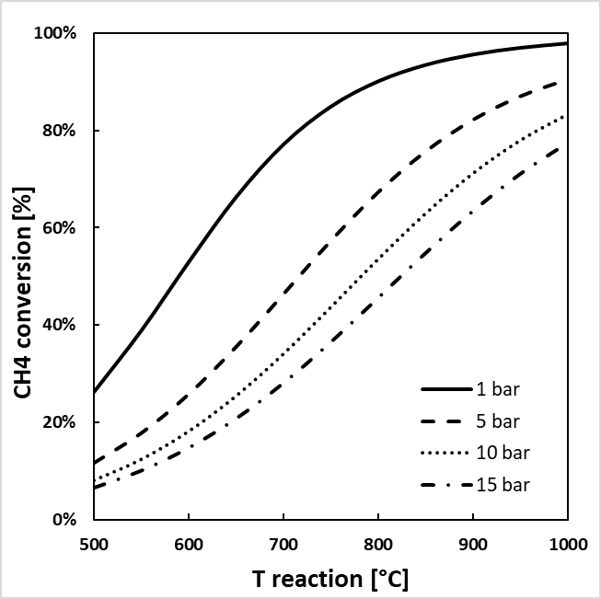
Figure 1: CH₄ equilibrium conversion at different temperature [°C] and pressure [bar] calculated on Aspen Plus v11
Catalyst addition enables the reduction of activation energy to the range 96.1-236 kJ/mol according to the catalyst type. Regardless of whether methane cracking is catalytic or not, the main problem is the cumulative deposition of coke which can plug not only the catalyst, but the reactor itself after a few hours of operation. A possible solution can be to make the reaction occur in a molten media in liquid bubble column reactors (Rahimi et al., 2019). In this way, the carbon can be easily separated in continuous operation since the low-density solid carbon ﬂoats on the surface of the liquid preventing carbon accumulation and blockage of the reactor. This solution represents still a challenge for the applicability on an industrial scale (Abánades et al., 2012).
Molten media present other advantages such as improvement of heat transfer and thermal inertia due to its heat capacity, increase of the residence time due to the liquid viscosity, enable of efficient heating using renewable electricity to replace fossil fuel combustion. Furthermore, the liquid phase can also catalyse the reaction (Msheik et al., 2021).
Molten media can be both molten salts and molten metals. Molten salts as liquid media have been investigated for many centuries in metal extraction, glass manufacturing, and, recently, fused-salt electrolysis, pyrolysis of hydrocarbons including propane, and cracking of aromatic compounds (Msheik et al., 2021). Molten salts are less expensive than metals and less dense due to high intermolecular interactions, and therefore with the same volume of the reactor, the amount of salt needed will be less. Furthermore, the molten salt contaminated by carbon would be easier to purify, as the salt dissociates in water (Rahimi et al., 2019). Molten metals show higher performance in terms of catalytic activity than salts. In particular, Ni, Pd, Pt, Co and Fe have a high catalytic behaviour, while In, Ga, Sn, Pb and Bi are considered inert metals or with low catalytic activity, even if their combination could highly modify the alloy activity and bring unexpected results, exceeding the performance of active metal alloys (Msheik et al., 2021; Catalan & Rezaei, 2020). Furthermore, molten metals should offer isothermal conditions during cracking, generally having high thermal conductivities. Therefore, they can homogenize the temperature, enhancing methane decomposition. Finally, in the case the use of solar energy, molten metal high thermal capacitance can protect the process from thermal shocks due to solar energy variations (Msheik et al., 2021). As summary of these studies, it can be concluded that the main factors playing a role in the cracking are the high temperature, the high residence time in the liquid phase and the production of small bubbles along the reactor. For the latter point, a porous distributor becomes essential since the small bubbles allow higher gas-liquid interfacial areas for the cracking reaction.
For this work, the scale up of a liquid bubble reactor using as sparger a Mott porous metal ﬁlters was analysed. Molten tin was chosen as molten metal since it presents: I) no volatility problems, II) relatively low melting point (T=232°C), III) high thermal conductivity and IV) low viscosity over 1000°C; these features favour a good mixing and effective heat exchange between the gaseous and liquid phases. In the following section the techno-economic assessment for a capacity of 100Nm³/h of H₂ is addressed.

Process scheme
The reactor analysed is a liquid bubble column reactor as shown in Figure 2. The methane enters inside the molten tin bath as bubbles which decompose under the high temperature. The bubbles open at the upper interface of the liquid media and the carbon and hydrogen are released (Sanchez-Bastardo et al., 2020). The carbon does not affect the reaction zone inside the bubbles: it floats on top of the liquid metal surface, rises with the bubbles, and is deposited at the surface of the liquid column (Msheik et al., 2021; Sanchez-Bastardo et al., 2020).
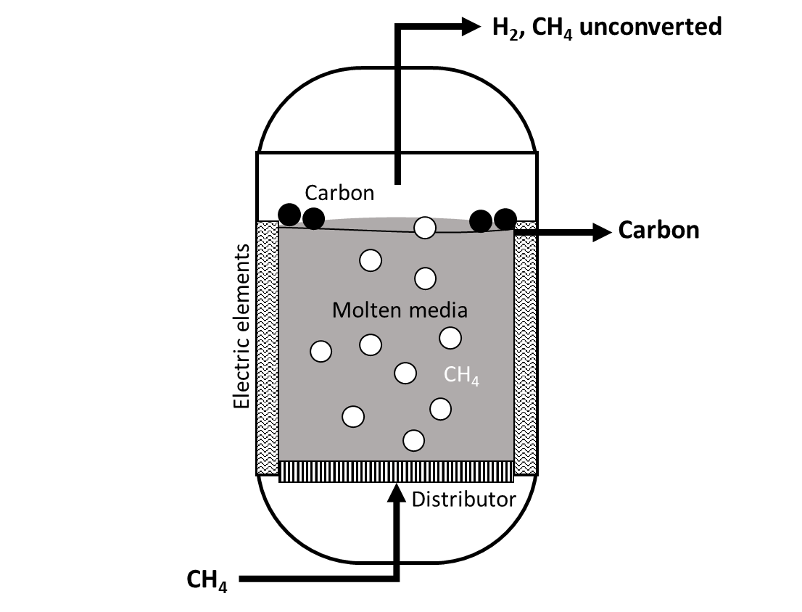
Figure 2: CH₄ cracking reactor scheme
A mathematical model, validated by laboratory experimental data, was realized to calculate the CH₄ conversion taking in account kinetics equations for the cracking reaction. The process scheme reported in Figure 3 was simulated on AspenTech Plus v.11 by Aspen Tech for a capacity of 100 Nm³/h of Hydrogen.

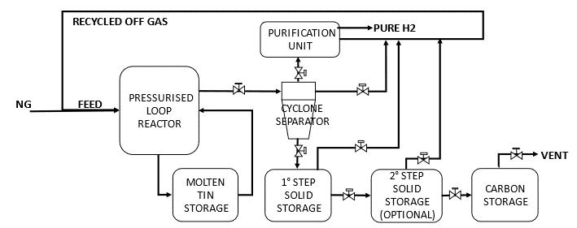
Figure 3: Simplified process scheme
Table 1: General assumptions for the process simulation on Aspen Plus v11
Property | Unit | Value
NG Battery Limit T | °C | 25
NG Battery Limit P | bar | 18.5
H₂ capacity | Nm³/h | 100
H₂ Battery Limit T | °C | 50
H₂ Battery Limit P | bar | 12
Reactor T | °C | 1000
Reactor P | bar | 15
PSA recovery | % | 75

The natural gas supply is preheated to around 500°C by heat recovery on the gaseous products leaving the reactor and fed to the reactor filled with liquid tin. The metal is maintained at a constant temperature of 1000°C by electrodes immersed in the molten bath. A gas distributor is placed at the bottom of the reactor to optimize both heat exchange and mass transfer by delivering microscopic-sized bubbles to maximize the liquid-gas interface. The products are cooled by a nitrogen stream before entering the cyclone with a substantial pressure drop to separate the solid coke from the gas stream. Both streams leaving the cyclone are cooled with a nitrogen stream to 40°C to meet the operating conditions of the PSA (the purification unit in Figure 3). PSA separation efficiency was assumed 75%. The purge gas from PSA is compressed and recirculated to the reactor. The amount of nitrogen required for cooling was used to produce work with an organic Rankine cycle.
As written above, the conversion is strongly influenced by the diameter of the gas bubble since increases as the bubble diameter decreases. Therefore, two different bubble diameters were analysed which led to two different conversion value at 1000°C and 15 bar, as reported in Table 2. As reported in literature, with a small bubble diameter, higher conversion can be reached.
Table 2: CH₄ conversion at 1000°C and 15 bar at two different bubble diameters
 | Bubble diameter | CH₄ conversion
Case A | 20 mm | 53%
Case B | 2 mm | 72%

Techno-economic assessment
The Variable Operating Cost (VOC) is calculated starting from the Heat and Materials balances evaluated on Aspen Plus. Table 3 reports the consumptions and the VOC for both case A and case B (see definition in Table 2). The main consumptions are the Natural Gas feed and the electric power for the reactor and the machineries, from which the power generated by the organic Rankine cycle was deducted (about 10KW for both cases). To calculate VOC, a price of 0.5 €/Nm³ and 150 €/MWh for Natural Gas and electricity was respectively fixed. The process fluids (tin, nitrogen and iso-pentane for Rankine cycle) have not been included in this evaluation, but in the total investment cost since they mainly operate in a closed cycle.
Table 3: Total Consumptions and VOC calculation [€/Nm³ H₂] for Case A and Case B
 | CASE A |  |  |  |  |  | CASE B
 |  | Consumption |  | VOC |  | Consumption |  |  | VOC
NG feedstock |  | 53.3 | Nm³/h | 0.27⁽¹⁾ | €/Nm³ H₂ | 52.0 |  | Nm³/h | 0.26⁽¹⁾ | €/Nm³ H₂
Tot. Power |  | 111.3 | kW | 0.17⁽²⁾ | €/Nm³ H₂ | 98.7 |  | kW | 0.15⁽²⁾ | €/Nm³ H₂
VOC |  |  |  | 0.43 | €/Nm³ H₂ |  |  |  | 0.41 | €/Nm³ H₂
(1) NG cost: 0.5 €/Nm³ NG; (2) Electricity cost: 150 €/MWh

The capital investment is the initial expense carried out to enable the purchase and installation of the process plant and is the combination of two elements: fixed capital and working capital. The fixed capital is the money necessary to purchase and install all the material and equipment necessary for the complete operation of the plant. So, in the overall, the amount of fixed capital investment corresponds to the total means spent to bring an industrial project from preliminary feasibility studies to actual start-up of the plant. Working capital represents an additional investment above the fixed capital, to enable the start-up of the plant and its operation until income is earned. The accuracy of capital cost estimates usually depends on the available design details, the accuracy of the cost data, as well as the time available to prepare estimates (Feng & Rangaiah, 2011). The commonly accepted classification of capital cost estimates is published by the Association for the Advancement of Cost Engineering (AACE, 2019). In this work, the fixed capital investment (FCI) is calculated based on the total equipment costs. Starting indeed from the equipment cost (reported in Table 4), it is possible to calculate the cost of different items such as piping, instrumentation, buildings, structures and auxiliaries’ costs, as percentages of it. These multiplying factors are available in literature and are optimized based on company experience. Thanks to this method, it is possible to estimate the FCI as the sum of all these different items and other assets such as catalyst, service fluid and etc.
The H₂ Cost of Production (COP) is calculated as the sum of Variable Operating Costs, depreciation and maintenance & operation (Table 5).The depreciation represents the initial or new value of a plant minus the value of the same plant at the end of the depreciation period, assuming that during operation a continuous deterioration and wear of materials of construction and operating equipment may bring a lower production efficiency. In engineering design practice, the total depreciation period is ordinarily assumed to be the length of the property’s useful life, and the value at the end of the useful life is assumed to be the probable scrap or salvage value of the components making up the particular property. Operating and Maintenance (O&M) for the overall plant is calculated based on Fixed Capital Investment. Labour cost has not been considered. Depreciation and O&M are calculated based on Fixed Capital Investment, as respectively 10% (which correspond to a depreciation period of 10 years) and 5%.
Table 4: Equipment and fluids cost [€] for Case A and Case B
 | Case A | Case B
Tot Equipment Cost [k€] | 240 | 230
Tin [k€] ⁽¹⁾ | 32.8 | 32.8
Nitrogen [k€] ⁽²⁾ | 16.1 | 13.2
Isopenthane [k€] ⁽³⁾ | 16.6 | 13.6
(1) Tin cost: 43 €/kg; (2) Nitrogen cost: 20 €/kg; (3) Iso-penthane cost: 40 €/kg
Table 5: COP [€/Nm³ H₂] for Case A and Case B
 |  | Case A | Case B
Fixed Capital Investment | k€ | 1236 | 1201
Maintenance & Operation | €/Nm³ H₂ | 0.08 | 0.08
Depreciation | €/Nm³ H₂ | 0.15 | 0.15
VOC | €/Nm³ H₂ | 0.43 | 0.41
COST of PRODUCTION | €/Nm³ H₂ | 0.66 | 0.63

To conclude, a comparison with the SMR with carbon capture in post combustion with a specific amine and the electrolysis was made to determine the potential of the methane cracking respect to these benchmarks. The main assumptions for both the processes are made based on company know-how and are reported in Table 6. Combing all the numbers in Table 6, a cost of production of 0.78 €/Nm³ of H₂ can be obtained for SMR+CCS and of 0.84 €/Nm³ of H₂ for electrolysis. As a result, methane cracking presents a reduction in COP of 14% and 25% respect to SMR+CCS and electrolysis respectively.
Table 6: Main assumptions for SMR with CCS and electrolysis for a capacity of 100 Nm³/h of H₂
 |  | SMR+CCS | Electrolysis
Fixed Capital Investment | k€ | 2000 (internal source) | 750 (IEA, 2022)
Electric power | kWh/Nm³ H₂ | 0.9 | 5.0
NG consumption | Nm³ NG/Nm³ H₂ | 0.5 | 0
CO₂ emission | Kg CO₂/Nm³ H₂ | 0.1 | 0

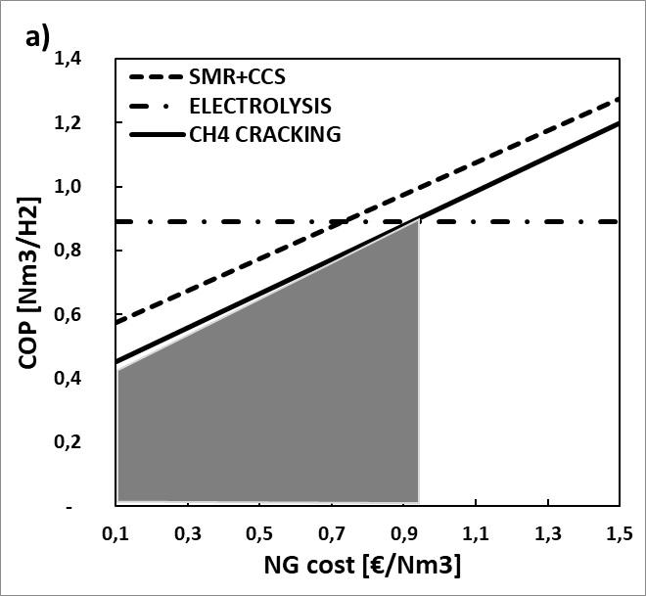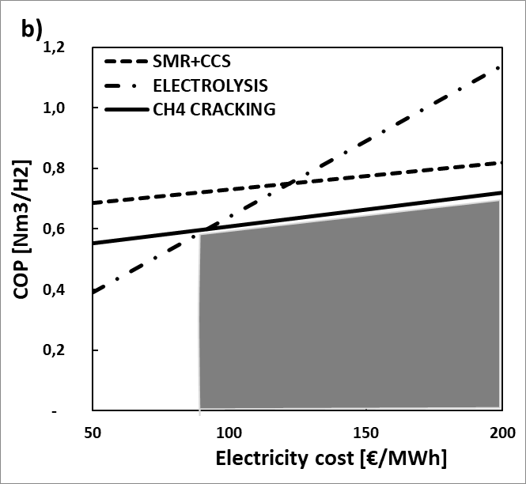
Figure 6: H₂ cost of production trend at different NG cost (a) and electricity cost (b) for CH₄ cracking, SMR+CCS and electrolysis.
It is important to highlight that the data for a SMR+CCS have been scaled from a centralized application: for this small capacity the CCS technology based on amine may be not practicable.
Finally, a sensitivity analysis on NG and electricity cost was carried out to analyse the VOC influence on the COP of the tree processes (Figure 6). The grey area represents the range of NG price and electricity price where CH₄ cracking results more convenient than SMR with CCS and electrolysis.

Conclusion
The recent interest in methane cracking is mainly due to the fact that the production of hydrogen takes place without CO₂ emissions. The aim of this work is to perform a preliminary techno-economic assessment of the methane cracking on molten metals, in particular on molten tin, for a production of 100 Nm³/h of hydrogen, to understand the future potentials of this technology. The aim is to move to a large capacity by increasing the size of the reactor and in parallel the number of units working in parallel.
The revenue from the solid carbon sale was not considered at the moment since the market is still evolving; in the future, this could further increase the potential of the process.
The results obtained showed that for small capacity, methane cracking is comparable with industrially benchmark processes such as SMR with carbon capture and electrolysis. A reduction in the H₂ cost of production of 14% and 25% respect to SMR+CCS and electrolysis respectively. Methane cracking on molten metals certainly represents one of the most competitive technologies on the market for low-capacity hydrogen production, even if some limitations for the industrial deployment are still to be overcome mainly related to the carbon removal from the reactor.
Nomenclature
COP – Cost of Production
FCI – Fixed Capital Investment
NG – Natural Gas
O&M – Operating and Maintenance
SMR – Steam Methane Reforming
PSA – Pressure Swing Adsorption
VOC – Variable Operating Cost
References
AACE, 2019. International Recommended Practice, COST ESTIMATE CLASSIFICATION SYSTEM – AS APPLIED IN ENGINEERING, PROCUREMENT, AND CONSTRUCTION FOR THE PROCESS INDUSTRIES. No. 18R-97, , Rev March 6, 2019 ed. s.l.:s.n.
Abánades A., Rubbia C., Salmieri D., 2012. Technological challenges for industrial development of hydrogen production based on methane cracking. Energy, Volume 46, pp. 359-363.
BakerMcKenzie, 2020. Shaping Tomorrow's Global Hydrogen Market via de-risked investments, s.l.: s.n.
Bartholomew C. H., 2001. Mechanism of catalyst deactivation. Chem. Eng. J., 212(17).
Catalan L. J., Rezaei E., 2020. Coupled hydrodynamic and kinetic model of liquid metal bubble reactor for hydrogen production by noncatalytic thermal decomposition of methane. International journal of hydrogen energy, Volume 45, pp. 2486-2503.
Feng Y., Rangaiah G., 2011. Evaluating Capital Cost Estimation Programs. s.l.:Chemical Engineering.
Harrison, S. B., 2021. Turquoise hydrogen production by methane pyrolysis. PTQ Q4.
IEA, 2022. Global Hydrogen Review, s.l.: s.n.
IEA, 2023. Energy Technology Perspectives 2023, s.l.: s.n.
IEA, November 2021. Hydrogen, s.l.: s.n.
Msheik M., Rodat S., Abanades S., 2021. Methane Cracking for Hydrogen Production: A Review of Catalytic and Molten Media Pyrolysis. Energies, 14(3107).
Parfenov V., Nikitchenko N. V., Pimenov A. A., Kuz’min A. E., Kulikova M. V., Chupichev O. B., Maksimov A. L., 2020. Methane Pyrolysis for Hydrogen Production: Speciﬁc Features of Using Molten Metals. Russian Journal of Applied Chemistry, 93(5), pp. 625-632.
Pérez B. J. L., Jiménez J. A. M., Bhardwaj R., Goetheer E., van Sint Annaland M., Gallucci F., 2021. Methane pyrolysis in a molten gallium bubble column reactor for sustainable hydrogen production: Proof of concept & techno-economic assessment. International journal of hydrogen energy, Volume 46, pp. 4917-4935.
Rahimi N., Kang D., Gelinas J., Menon A., Gordon M. J., Metiu H., McFarland E. W., 2019. Solid carbon production and recovery from high temperature methane pyrolysis in bubble columns containing molten metals and molten salts. Carbon, Volume 151, pp. 181-191.
Sanchez-Bastardo N., Schlogl R., HolgerRuland, 2020. Methane Pyrolysis for CO2-Free H2 Production: A Green Process to Overcome Renewable Energies Unsteadiness. Chem. Ing. Tech., 92(10), pp. 1596-1609.

